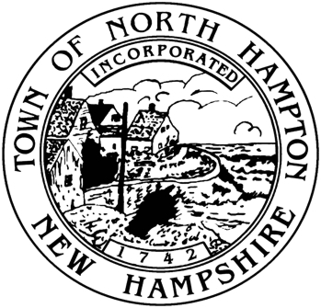

Municipal Offices

233 Atlantic Avenue

North Hampton, NH 03862

Tel: (603) 964-8087

Fax: (603) 964-1514

Jim Maggiore, Chair

Phil Wilson, Vice Chair

Larry Miller, Member

Town of North Hampton, New Hampshire

THE SELECT BOARD

PUBLIC NOTICE

It is possible that a quorum of the Select Board will be present at the New Hampshire Supreme Court on November 13, 2013 at 10:00 a.m. to listen to oral arguments in a case entitled *Appeal of the Town of North Hampton*. The New Hampshire Supreme Court is located at 1 Charles Doe Drive in Concord, New Hampshire.

A quorum may be present during all or part of the hearing.

There is no specific Select Board agenda and no minutes will be kept.